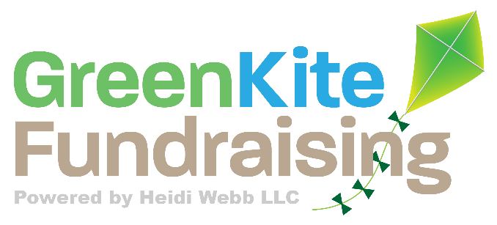

Fundraising TIPS

Timing is Everything!
Corporate Fundraising: November
Individual Fundraising: October – December
Private Foundation Grants: All year long – create a timeline!
Best times to post on social media:
- Facebook: Wednesday at 11 a.m. and 1 p.m.
- Instagram: Wednesday at 11 a.m. and Friday at 10–11 a.m.
- Twitter: Wednesday at 9 a.m. and Friday at 9 a.m.
- LinkedIn: Wednesday at 9–10 a.m. and 12 p.m.
Short List of Companies that Donate!
Apple
Know someone at Apple? Apple has an extremely generous employee matching gift program. They match donations as small as $1 all the way up to $10,000 per employee per year to nearly all 501(c)(3) organizations.
Boeing
Boeing encourages its employees to pool their donations together into a single gift. Boeing takes care of all administrative costs, so 100% of the given money goes towards strengthening local communities. Grants have helped projects such as:
- Fighting homelessness
- Job training for the unemployed
- Funding critical health services
- Supporting veterans programs
Disney
Disney offers financial and in-kind donations to the following groups, organizations, and causes: Children’s hospitals, disaster preparedness and relief, Military families and organizations that promote healthy lifestyles.
Express Scripts
The Foundation focuses on initiatives that enable access to health and medical services, including a focus on prevention, treatment, and research for chronic diseases and developmental disorders; racial health disparities; wellness programs promoting exercise, fitness, and healthy lifestyle choices; and prenatal and newborn programs. Military supportive!
Google
Through the Google Grants program, your nonprofit can request a donation of up to $10,000 dollars in free monthly advertising.

